**Section 1**

**Array**

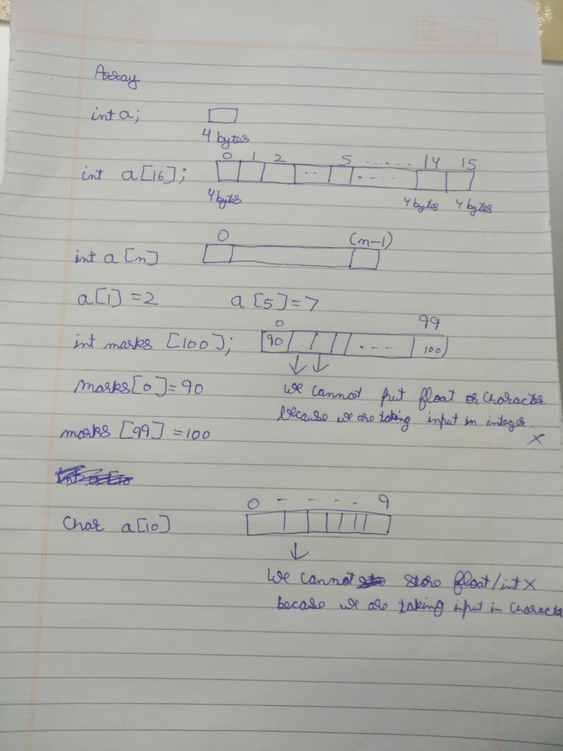

**Initializing array and edding values to it**

#include<iostream>

using namespace std;

int main(){

int a[10];

a[2]=4;

a[5]=9;

cout<<a[2]<<" "<<a[5]<<endl;

return 0;

}

**Output**

**4 9**

**Code to create an array and print values of it :**

#include<iostream>

using namespace std;

int main(){

int a[10] = {1,2,3,4,5,6,7,8,9,10};

for(int i=0;i<10;i++){

cout<<a[i]<<" ";

}

return 0;

}

**Output**

1 2 3 4 5 6 7 8 9 10

**Size of array is 10 but we are putting just 5 values to it … and printing all the 10 values … rest of the values become zero automatically…**

#include<iostream>

using namespace std;

int main(){

int a[10] = {1,2,3,4,5};

for(int i=0;i<10;i++){

cout<<a[i]<<" ";

}

return 0;

}

**Output**

1 2 3 4 5 0 0 0 0 0

**When we initialise an array and do not put values to it …. If we try to print the values of an empty array it will give garbage values as output**

#include<iostream>

using namespace std;

int main(){

int a[10];

for(int i=0;i<10;i++){

cout<<a[i]<<" ";

}

return 0;

}

**Output**

8 0 4199705 0 8 0 66 0 6887184 0

**These are garbage values**

**Code to put values into the array using for loop :**

#include<iostream>

using namespace std;

int main(){

int a[10];

for(int i=0;i<10;i++){

a[i]=i*i;

cout<<a[i]<<" ";

}

return 0;

}

**Output**

0 1 4 9 16 25 36 49 64 81

**Code to add elements in array …**

**Array Sum**

Open 1. Array sum code in folder …

**Code Largest Number in Array**

Open 2. Largest Number in Array code in folder …

**Code Smallest Number in Array**

Open 3. Smallest Number in Array code in folder…

**Code Largest Number and Smallest Number in Array**

Open 4. Largest and Smallest Number in Array code in folder…

**Code to Swap Numbers**

Open 5. Swap Numbers Code in Folder…

We will create a temp variable in it ..

a = 5 and b = 7

int temp

now we will put value of a in temp variable

temp = a

now temp also has value 5… which means temp = 5

put the value of b in a

a = b

now a has value of b which is 7… which means a =7

now put the value of temp in b which is 5… this means now b has value 5 …

so the numbers are swapped …

a = 7

b = 5

**Code Swapping using xor…**

**Logic here**

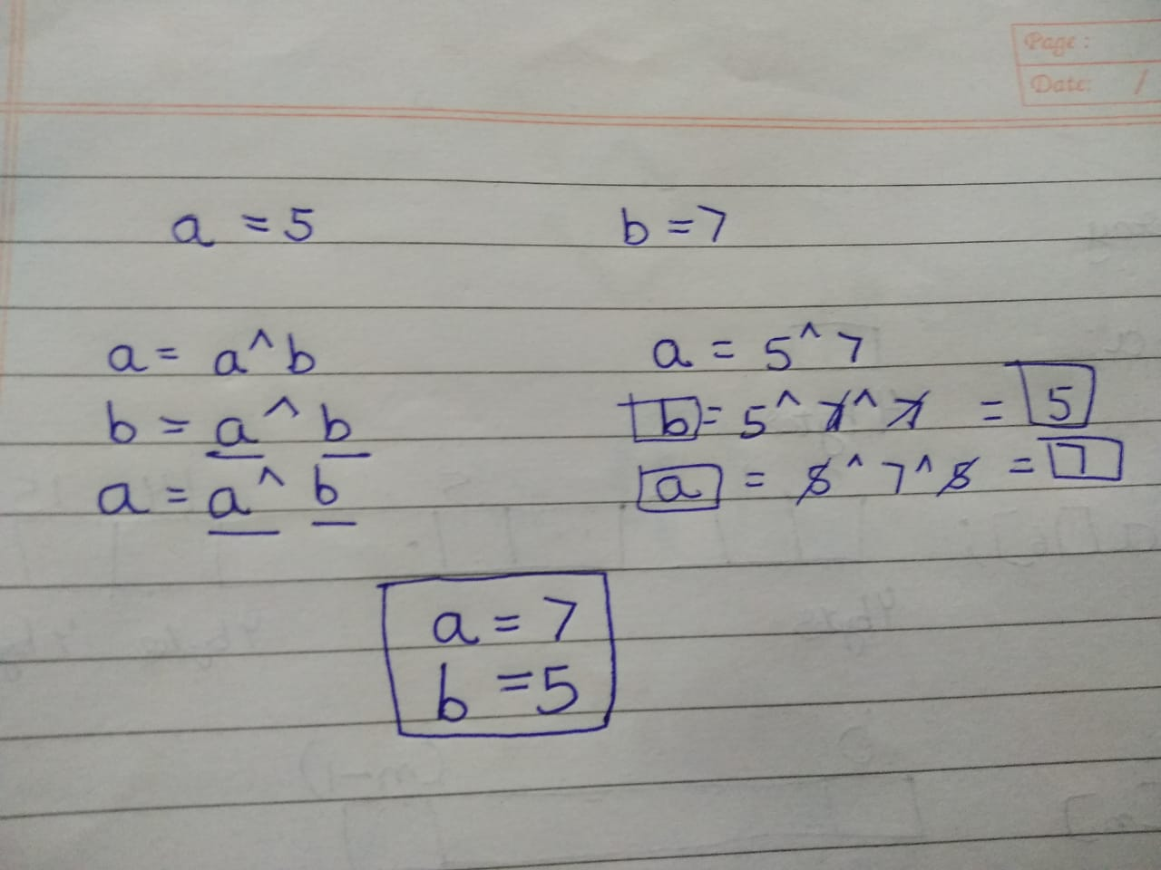

Open 6. Swap numbers using xor code in codes folder…

**Easy Swap numbers code**

Open 7. Easy swap numbers code in codes folder…

**Code Reverse Array**

Open 8. Reverse Array code in codes folder…

**Code character array**

Open 9. Character array code from codes folder…

char name[10];

it will create 10 boxes each of 1 byte…

total 10 bytes..

in character array we take input easily..

cin>>name;

if we want to print character array ... it is also easy ..

cout<<name;

if we want to enter character value at any position in array we do

cin>>name[5];

it will enter value at 6th place in array

**cin.getline(name, length, delimiter or break or null character)**

**cin limitations:**

1. If we enter abcd in char array [4] … and if we get output from it … it will return abcd \0 \0 \0 … null values at the end … this storage is not ours…
2. If we enter hello space world ( hello world ) in char array [10] … then we get output just hello\0 …. That space will be counted as null value …

that’s why cin.getline(name,length,optional break character) is better way to input char array …

**Command cin.getline(name, length, optional break character)**

**Now lets write a code…**

**cin.getline(name,19) /*this means we have 18 storage*/**

**if we do**

cin.getline(name,19,’o’) /*Now O will be considered as new line character or null value*/

if we take input as Hello World

and we will get output as Hell …only

O will be considered as null value so it will stop printing at O …